EXPT NO:3 | Designing Multivariate Patterns
DATE: 12.01.2026 | Designing Multivariate Patterns

PRE-LAB QUESTIONS (PROVIDE BRIEF ANSWERS TO THE FOLLOWING QUESTIONS)
- Why is multivariate analysis essential in real-world AI problems?
Multivariate analysis is essential because real-world AI problems involve multiple interacting variables. It helps capture complex relationships, dependencies, and patterns that cannot be understood using single-variable analysis.
- What challenges arise when visualizing high-dimensional data?
High-dimensional data visualization can lead to cluttered plots, overlapping data points, and difficulty in interpretation. Dimensionality reduction and advanced visualization techniques are often required to maintain clarity.
- How does correlation analysis support feature selection?
Correlation analysis identifies relationships between features and the target variable, helping select relevant features and remove redundant or highly correlated ones to improve model performance.
- What are ethical concerns in healthcare data visualization?
Ethical concerns include patient privacy, data anonymity, misinterpretation of results, and biased visual representations that may lead to incorrect medical decisions.
- Give examples of multivariate data in AI systems.
Examples include patient health records (age, symptoms, test results), e-commerce transactions (price, quantity, time, customer behaviour), and sensor data in autonomous systems (speed, distance, temperature).

IN-LAB EXERCISE:

OBJECTIVE:

To discover relationships among multiple variables using multivariate visualization.

SCENARIO:

A hospital analytics team studies patient health records to identify relationships between age, BMI, glucose levels, and blood pressure for early disease prediction.

IN-LAB TASKS (Using R Language)
- Generate scatter plot matrix
- Apply colour encoding for age groups
- Identify correlated health indicators

Code:

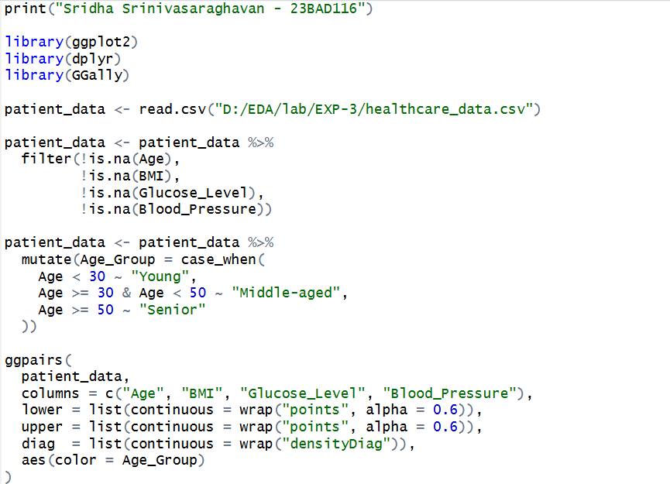

Output:

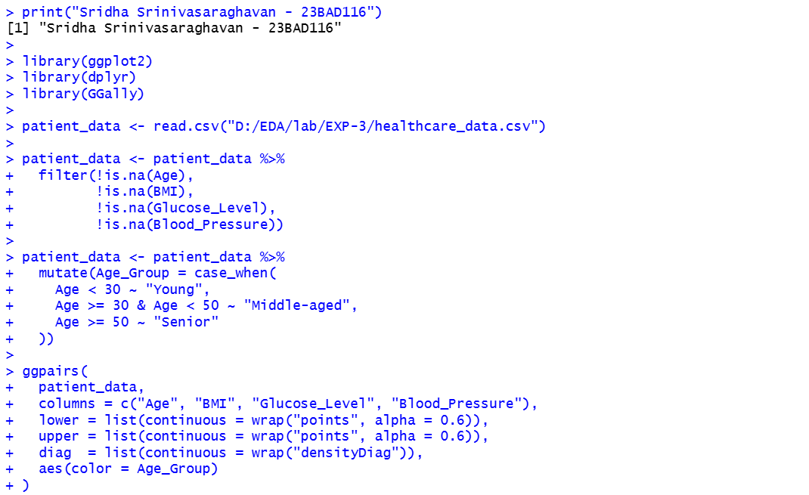

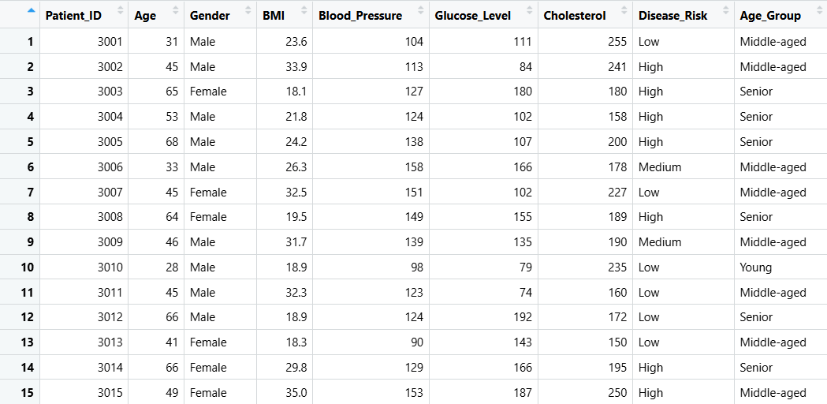

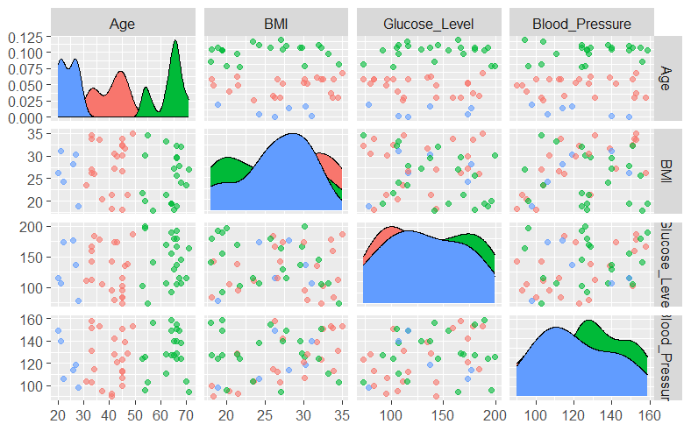

POST-LAB QUESTIONS (PROVIDE BRIEF ANSWERS TO THE FOLLOWING QUESTIONS)

- Which health parameters show strong correlation?

BMI and glucose levels, as well as age and blood pressure, show strong correlation, indicating increased health risk with higher body mass and aging.

- Why does correlation not imply causation in medical data?

Correlation only shows association and does not confirm that one factor directly causes another, as medical outcomes are influenced by multiple confounding variables.

- How can these patterns assist predictive healthcare AI?

Identified patterns help AI models select relevant features, improve risk prediction accuracy, and enable early disease detection and preventive care planning.

- What visualization limitations exist for high-dimensional data?

High-dimensional data leads to cluttered visuals, overlapping points, and reduced interpretability, making patterns difficult to identify clearly.

- How can dimensionality reduction improve visualization?

Dimensionality reduction techniques like PCA reduce variables while preserving key patterns, enabling clearer visualization and easier interpretation.

ASSESSMENT
Description | Max Marks | Marks Awarded
Pre Lab Exercise | 5
In Lab Exercise | 10
Post Lab Exercise | 5
Viva | 10
Total | 30
Faculty Signature

